Tutorial 4

1. (a) Able to capture sound accurately. Takes up more space

(b) Quantization doesn't remove data from our input, it actually adds in a noisy error signal.

(c)

$$\frac{Quantization \left(bit\right)× Sampling Rate \left(Hz\right)×Channels ×Duration\left(s\right)}{8 ×1024}$$

$$=\frac{8× 8000×1 ×60}{8 ×1024}$$

$$=468.75 KB$$

(d)

$$\frac{Quantization \left(bit\right)× Sampling Rate \left(Hz\right)×Channels ×Duration\left(s\right)}{8 ×1024}$$

$$=\frac{16× 44100×2 ×30}{8 ×1024}$$

$$=5167.97 KB$$

$$\frac{5167.97}{1024} =5.05 MB$$

1. (a)

Calculation of 24-bit bmp file size in KB:

$$\frac{Width \left(px\right)× Height\left(px\right) ×Bit Depth}{8 ×1024}$$

$$=\frac{50× 50 ×24}{8 ×1024}$$

$$=7.32 KB$$

Calculated file size is 7.32KB (7500B)

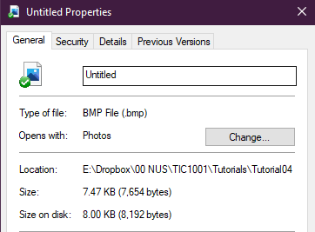

Actual file size is 7.47KB (7654B)

(b)

R=38, G=190, B=217

R:

38/16 = 2 R 6

2 / 16 = 0 R 2

G:

190/16 = 11 R 14

11 / 16 = 0 R 11

B:

217 / 16 = 13 R 9

13 / 16 = 0 R 13

RGB -> HEX = 2-6-11-14-13-9 = 26BED9

(c)

1 character = 8b = 1B

$$1B×6 char×2500 copies=15000B=1500KB$$